**Department of Electronics and Telecommunication Engineering**

**Module wise University Questions**

**(First Half of 2023)**

**Class/Sem: BE/VIII Branch: EXTC**

**Subject: OCN**

**Module 1: Introduction and basics of optical fiber communication**

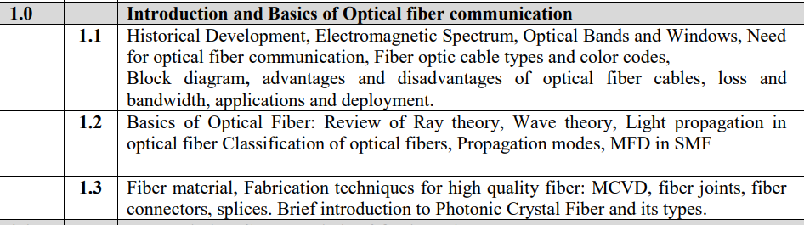

**Dec 2019**

1. Explain different types of fibers with their refractive index profile and-mention its 5 dimensions. [5m]
2. Derive expression for cut off wavelength for single mode step Index fiber. [5m]
3. If a multimode step Index fiber having the core refractive index of 1.5, cladding refractive index of 1.38, core radius of 25 um operates at a wavelength of 1300 nm. Calculate:
4. Numerical Aperture
5. Normalized frequency
6. Solid acceptance angle
7. Total no. of modes entering the fiber. [10m]
8. Write short note on (i) RF over Fiber [5m]

**May 2019**

1. What is the Numerical Aperture of Fiber? Give its significance [5m]

**Dec 2018**

1. Define Critical Angle, Acceptance and Numerical Aperture and quantum efficiency. [5m]
2. A typical relative refractive index difference for an optical fiber designed for long distance transmission is 1 %. Estimate NA and solid acceptance angle in the air for the fiber when the core index is 1.46. Further calculate the critical angle at the core cladding interface within the fiber. It may be assumed that the concept of geometric optics hold for the fiber. [10m]

**May 2018**

1. Explain three operating windows in optical communication [5m]
2. A silica optical fiber has core refractive index of 1.4 and cladding index of refraction is 1.35. Determine
3. The critical angle
4. Numerical
5. The acceptance angle [10m]
6. A silica optical fiber with core diameter large enough to be considered by Ray theory has a core refractive index of 1.5 and cladding refractive index of 1.47. Determine:

i. The critical angle.

ii. The NA.

iii. The acceptance angle[10]

**Dec 2017**

1. Define Fresnel Reflection, Numerical Aperture and V-number [5m]

**May 2017**

1. Define Critical Angle, Acceptance Angle, Fresnel Reflection and External Reflection.[5m]
2. Calculate the number of modes at 1.3 μm wavelength in GIF having index profile α =2, core radius 25 μm, core refractive index 1.48 and cladding refractive index 1.46. [5m]
3. Sketch the Refractive Index Profile of SIF and GIF. Derive an expression for Numerical Aperture and Number of Modes in SIF. [10m]

**May 2016**

1. Derive the expression for cut off wavelength for single mode transmission [10m]
2. A silica optical fiber has core refractive index of 1.4 and cladding index of refraction is 1.35. Determine
3. The critical angle
4. Numerical
5. The acceptance angle [10m]
6. Explain any one fiber fabrication process with neat diagram. Compare the different methods of fabrication.[10]
7. Explain different types of fibers with their refractive index profile and mention its dimensions.[05]
8. Starting from Maxwells equation, derive the wave equation for step index fiber?[10]
9. Short Note: Fiber Materials[05]
10. Describe two methods of splicing individual fibers together. What are the advantages and disadvantages of each method?[10]

**Dec 2015**

1. Draw the block diagram of optical communication and state its advantages and disadvantages. [10m]
2. Explain different types of fibers with their refractive index profile and mention its dimensions [5m]

**Dec 2014**

1. Explain three operating windows in optical communication.[05]

### A silica optical fiber with core diameter large enough to be considered by Ray theory has a core refractive index of 1.5 and cladding refractive index of 1.47.

### Determine:

i.The critical angle.ii.The NA.iii.The acceptance angle[10]

**May 2014**

1. What do you mean by Optical wave guide? How it is different from Electrical wave guide?[05]
2. Explain the significance of V-number. Derive the expression for number of guided modes in graded-index fiber.[10]
3. Explain the following terms:
   1. Total internal reflection
   2. Acceptance angle
   3. Critical angle[03]
4. Derive the expression of Numerical Aperture of Step- index fiber. What will happen to Numerical Aperture if cladding is removed?[05]
5. Compare step- index and graded-index fiber.[05]

**Dec 2013**

1. Explain the significance of V-number. Derive the expression for number of guided modes in graded-index fiber.[10]

**May 2013**

1. Draw the basic block diagram of optical fiber communication system?[05]
2. What are the desirable requirements of a good fiber optic connector? What are the lensing schemes for coupling improvements?[10]

### Draw refractive index profile of a graded index fiber and show with neat diagram transmission of light through this fiber. Explain how GRIN fiber has transmission bit rate much higher than multimode step index fiber.[05]

1. Draw the refractive index profile for the step index and graded index fiber. For each type give typical core and cladding diameters.[05]

**Dec 2012**

1. What are the advantages of optical fiber communication?[05]
2. Starting from Maxwells equation, derive the wave equation for step index fiber?[10]
3. Name the key parameters for describing the signal transmission in single mode fiber and multimode fiber.[05]
4. Explain the significance of V-number. Derive the expression for number of guided modes in graded-index fiber.[10]
5. Explain double Crucible method of fiber fabrication.[10]
6. Calculate the required Δ if a fiber with a 8 μm core and a 125 μm cladding is to be single mode at 1300 mm. Assume that the core index is 1.46.[05]

**May 2012**

1. Define the terms numerical aperture, critical angle, propagating modes and micro bands in the context of an optical fiber.[05]
2. graded index fiber[05]
3. Five connectors used in optical fiber communications.[05]
4. Numerical aperture in GIF.[10]
5. State the spectral band designations used in optical fiber communications?[05]
6. Define the terms numerical aperture, critical angle, propagating modes and micro bands in the context of an optical fiber.[10]
7. Calculate the required △ if a fiber with a 8μm core and a 125μm cladding is to be single mode at 1300 mm. Assume that the core index is 1.46[05]
8. What do you understand by degenerating modes in step index fiber?[05]
9. With a neat sketch explain fiber optic cable.[05]